Social Guide for Rivendell Theatre
an introduction for first-time visitors and families

Updated 12/10/21

MISSION

Rivendell Theatre Ensemble (RTE) elevates the lives of women through the power of theatre. We cultivate a creative home for audiences and artists to explore untold women’s stories while fostering an environment in which women theatre artists can thrive. Rivendell lifts up all female voices, promotes female-focused work creation, broadens awareness with fresh insights and dialogue, and advocates for women.
The Tasters, 2020
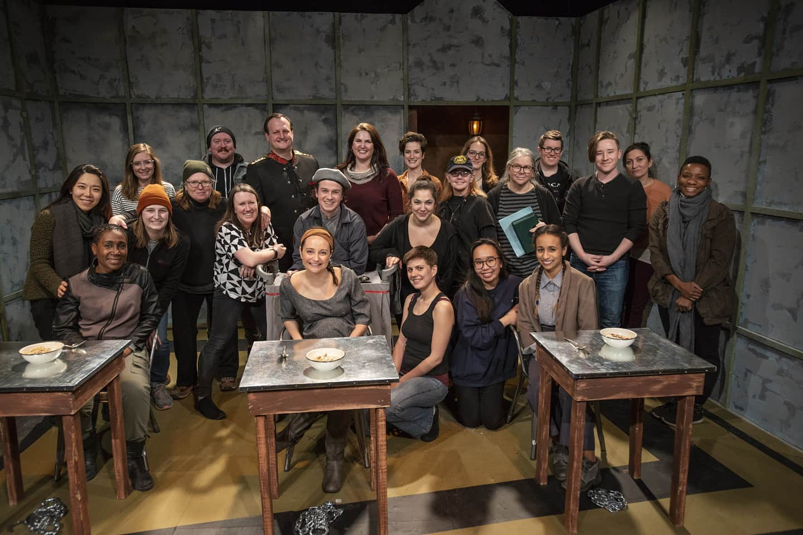

VALUES

We believe…
- Theatre offers a necessary platform for women whose stories have gone unheard and whose voices have long been silenced.
- Authentic stories transform us. They build understanding, empathy, and connection across individuals of different backgrounds and experiences.
- The work of women is both essential and undervalued.
- Women’s voices drive change. Our perspectives demand respect and a fundamental place in the world conversation.
- Embracing equity, diversity, and inclusion forges a path toward a just society.
- A family-friendly culture enables artists to do their best work.
- When we are united, we are unstoppable.

GETTING TO RIVENDELL

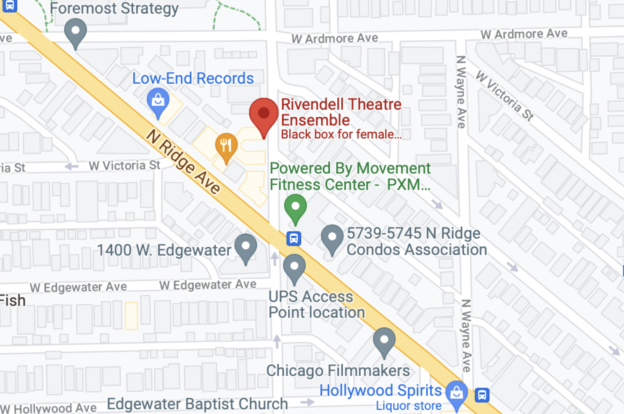

Rivendell Theatre Ensemble is located at 5775 N Ridge Ave. Chicago, IL, 60660. Our performances take place in the official Rivendell Theatre located inside our building.

BY THE “L”
- The nearest “L” stop is the Bryn Mawr stop on the red line which is approximately a 10 minute “walk” from the station to the theatre. According to CTA Accessible Services, the Bryn Mawr L stop does NOT offer an elevator.
- The nearest “L” stop that does offer an elevator is the Granville L stop which is approximately a 15 minute “walk” to the theatre

BY BUS
- The nearest bus stop is the Ridge/Glenwood stop on the 84 bus approximately a 1 minute walk from the stop to the theatre
- The second nearest bus stop is the Clark/Thorndale stop on the 22 bus approximately a 6 minute walk from the stop to the theatre
- The third nearest bus stop is the Edgewater/Clark stop on the 50 bus approximately a 7 minute walk from the stop to the theatre

BIKE SHARE
- A Divvy Bike station is located at Clark St. and Elmdale Ave.
- An additional Divvy Bike station is located at Broadway and Thorndale

BY CAR
- Limited street parking is available on Glenwood Ave as well as on Ardmore Ave. The street has a curb, with ramp options available intermittently.
- Free parking is just one block away at Senn High School. From Ridge Avenue:
  - Drive north on Glenwood and make the second left onto Thorndale (past the Senn High School building).
  - Continue to the stop sign at Greenview and turn left directly into the parking lot.
- After parking, exit on foot at the opposite end of the lot onto Ridge Avenue and turn left.
- Travel one block.
- The theatre is on the left at 5779 N. Ridge Avenue.

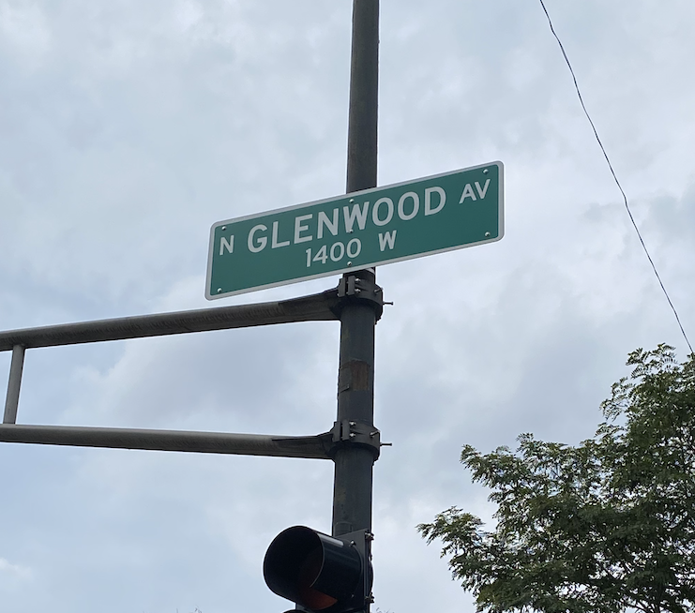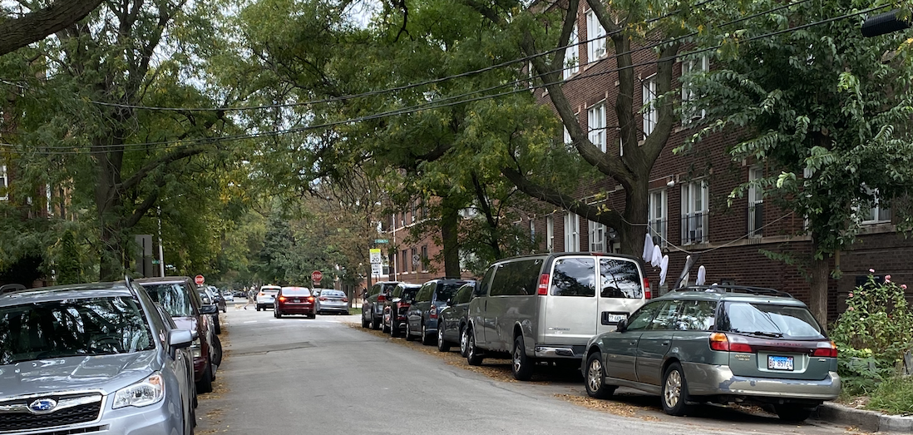

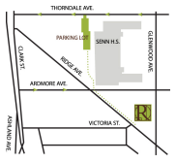

Here is the video on how to access the parking lot
https://www.youtube.com/watch?v=K7m_hJFBDSg

ENTERING THE SPACE

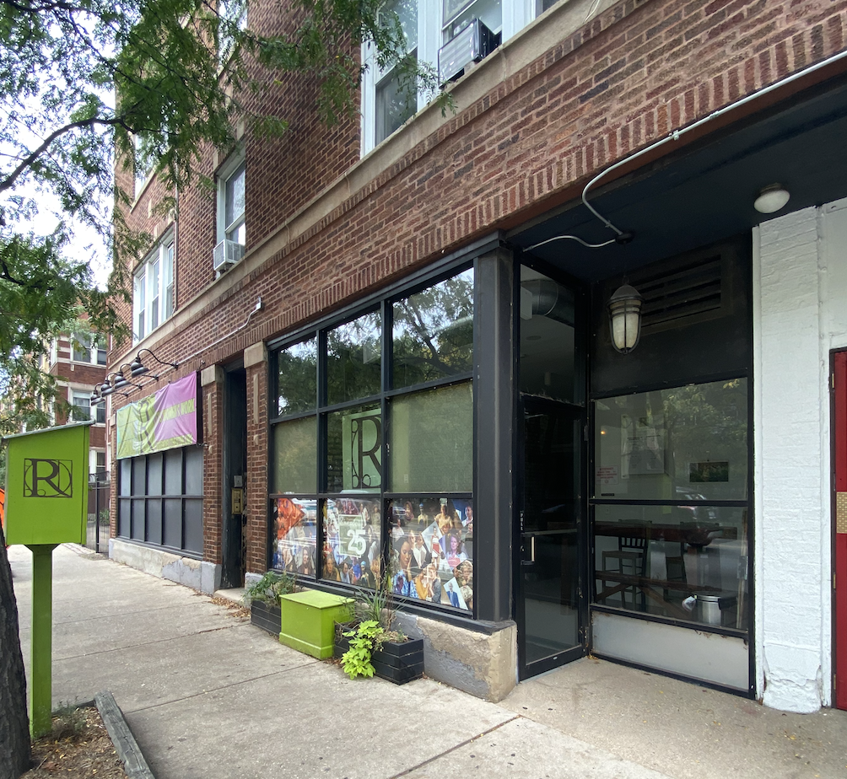
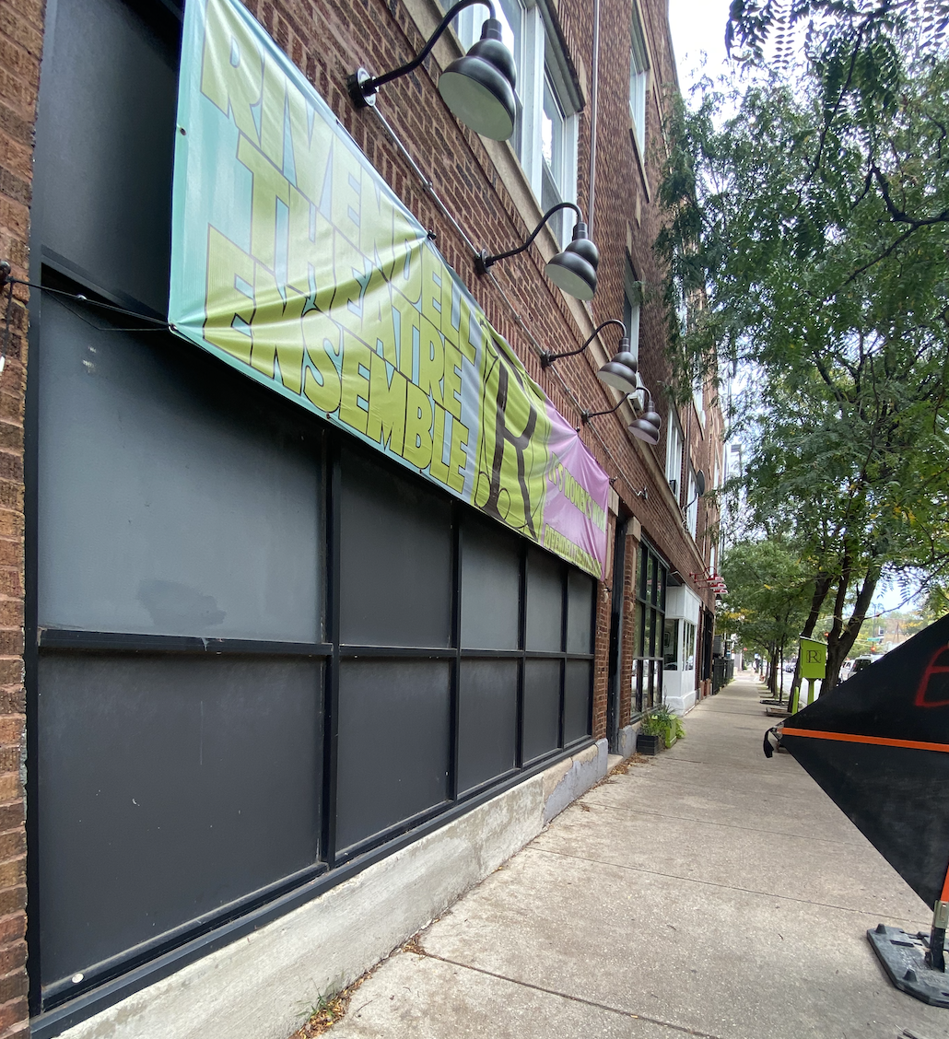
Street view of Rivendell Theatre

Front Door-34.5 in. wide
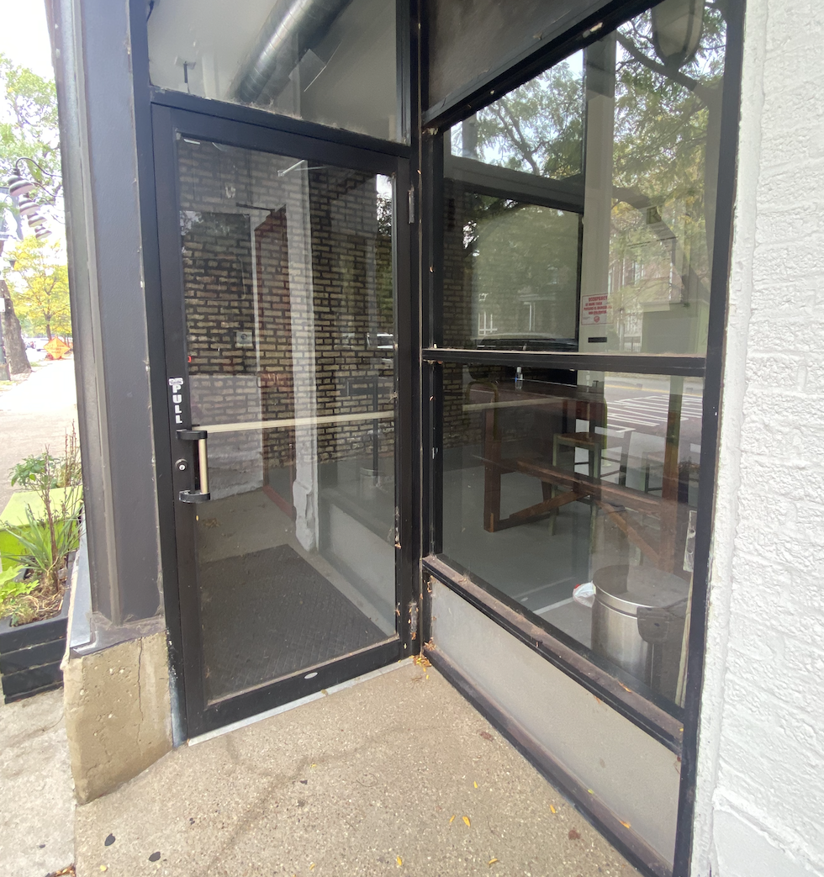

FRONT OF HOUSE EXPERIENCE & BOX OFFICE PROTOCOL

Congratulations! You’ve made it to Rivendell and your show will begin shortly! Upon entering our lobby, your experience will look a little like this:

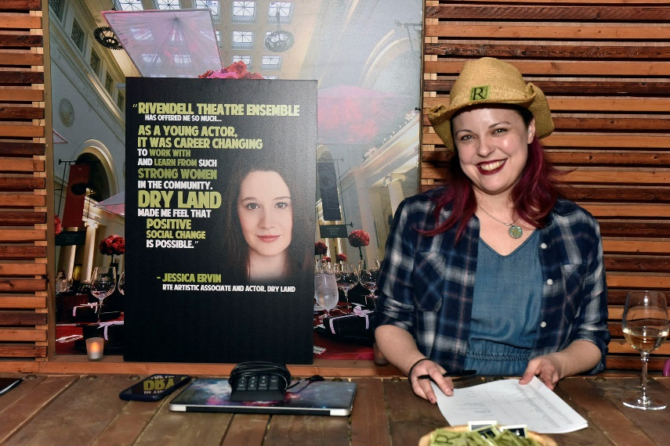
First, you will check in at our box office table where you will give one of our friendly staff members your name. Have proof of vaccination or negative test ready to show!

Next, the box office will hand you your ticket and tell you the run time of your performance, whether there's an intermission, how to get to the theatre, where the bathrooms are, and whether the house is open or not.

Finally, upon entering the theatre (door width 35"), you will receive your program from the usher at the theatre entrance and find a seat.

NOTE: If you need extra time and/or assistance getting to your seat, Rivendell is happy to invite you into the theatre before the house officially opens and assist you to your seat. Simply contact Rivendell in advance (phone number and email address at end of this document) or alert the Box Office staff when you arrive.

PURCHASING AND RECEIVING YOUR TICKETS

To purchase tickets for a show at Rivendell, visit our website at rivendelltheatre.org where you can select tickets for a single performance OR a FlexPass (a membership through which you can attend a Rivendell show any time).

Upon purchasing your tickets, you will receive a confirmation email. Your tickets will be held at will call – meaning you simply need to walk up to the Box Office desk and tell them your name. Your name will be on the list of ticket purchasers.

LOBBY AND THEATRE

RESTROOMS

There are two restrooms near the seating area, located in the theatre lobby. To access either of these restrooms once seated, audience members will need to exit the theatre and go up the ramp. Each restroom door-frame measures 35 inches wide.

One of our restrooms is a single accessible stall that includes one toilet and one sink. Our other restroom is a two stall that includes one standard toilet stall that is 30 inches wide, one accessible toilet stall that is 36 inches wide, and one sink.

Two-stall restroom
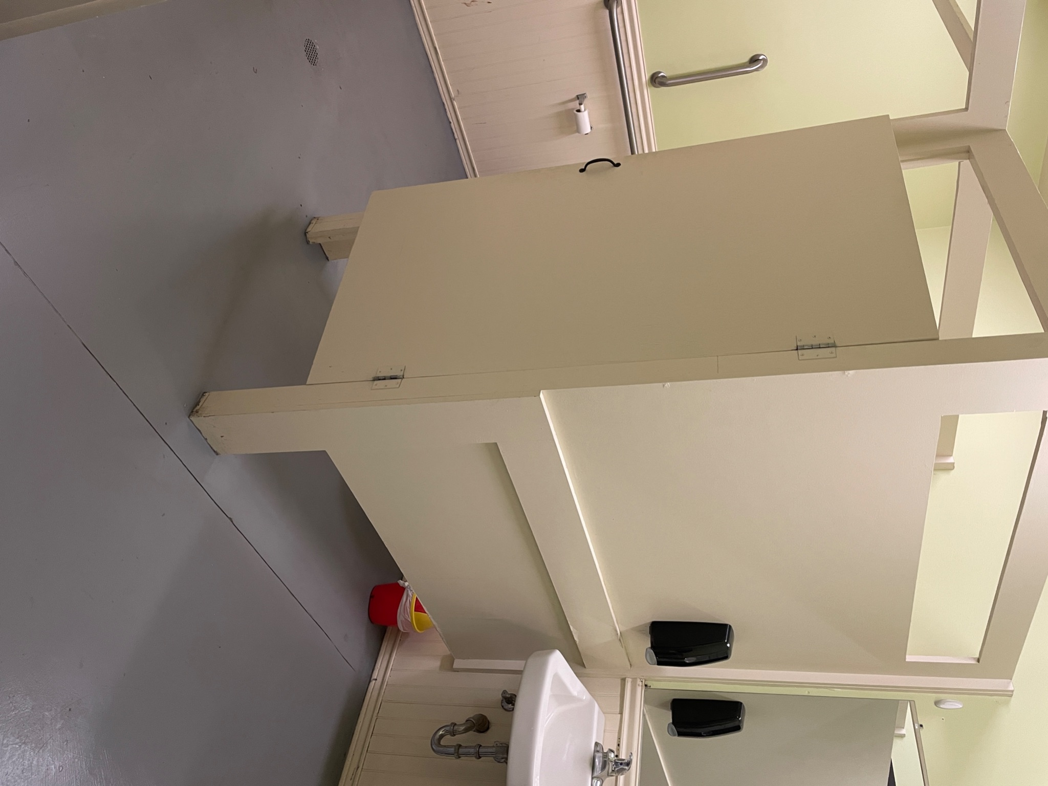
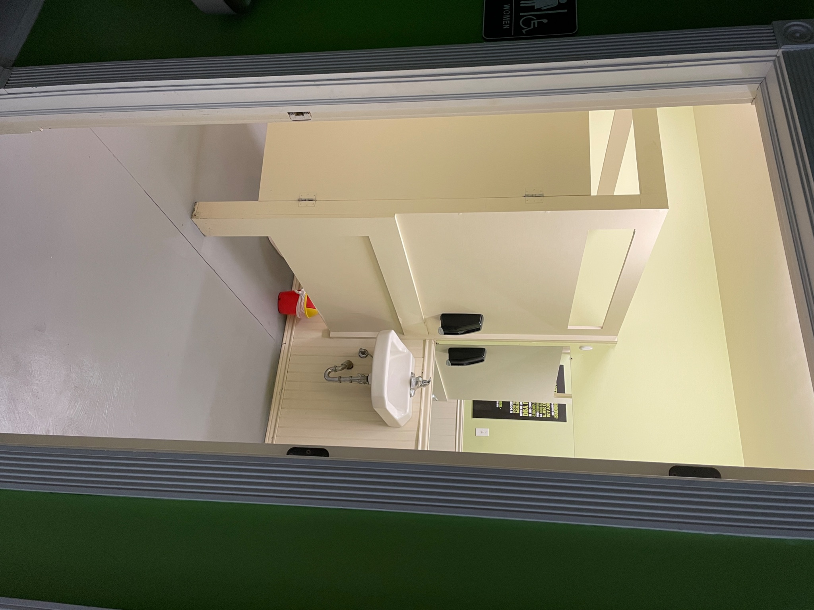

Single restroom
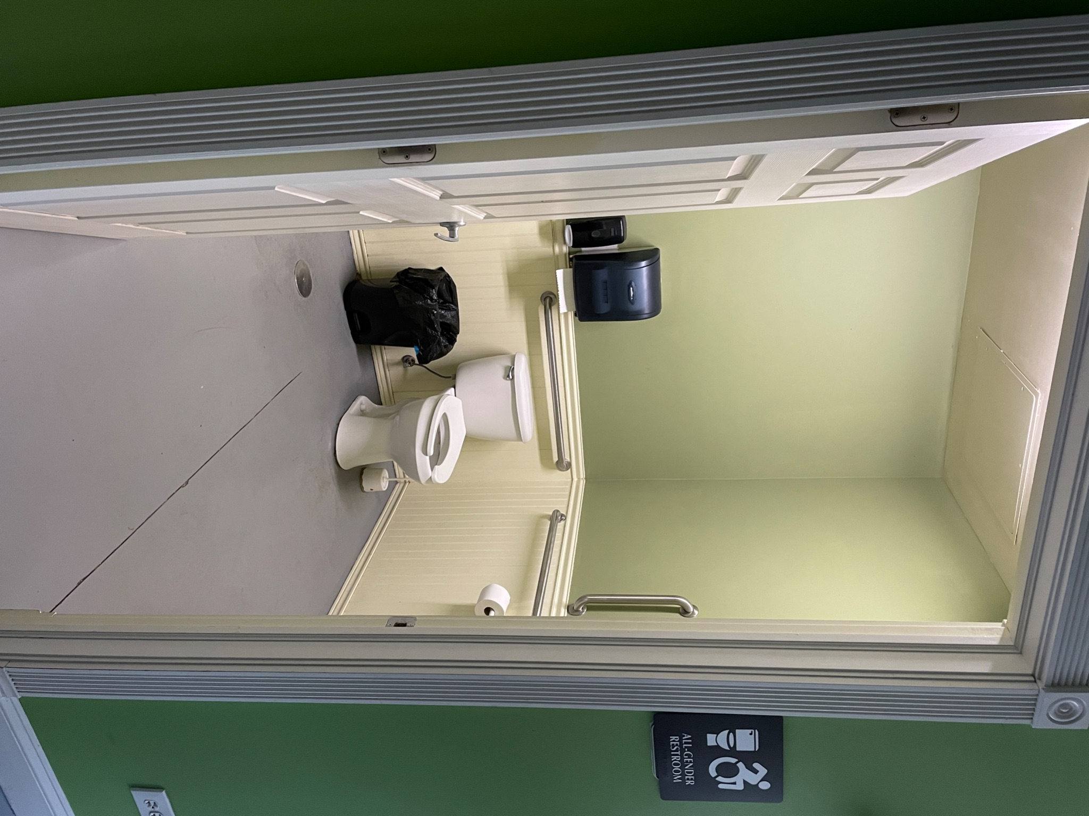

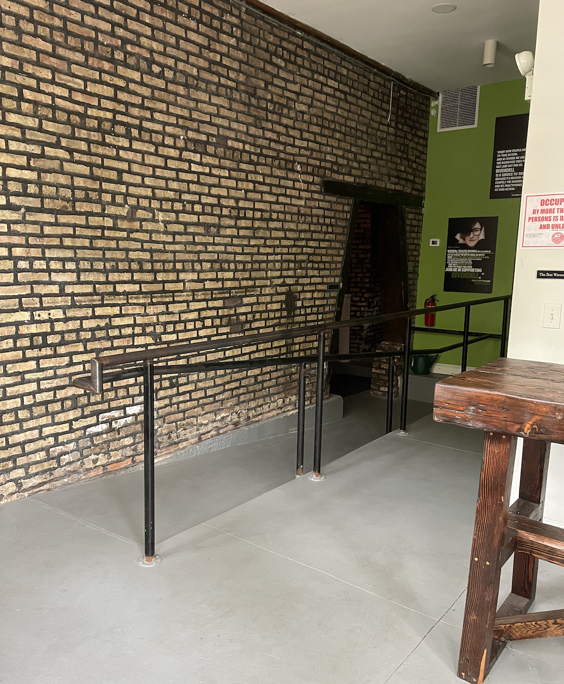
ENTERING THE SEATING AREA

The ramp leading to the seating area from the lobby is 43 in. wide.

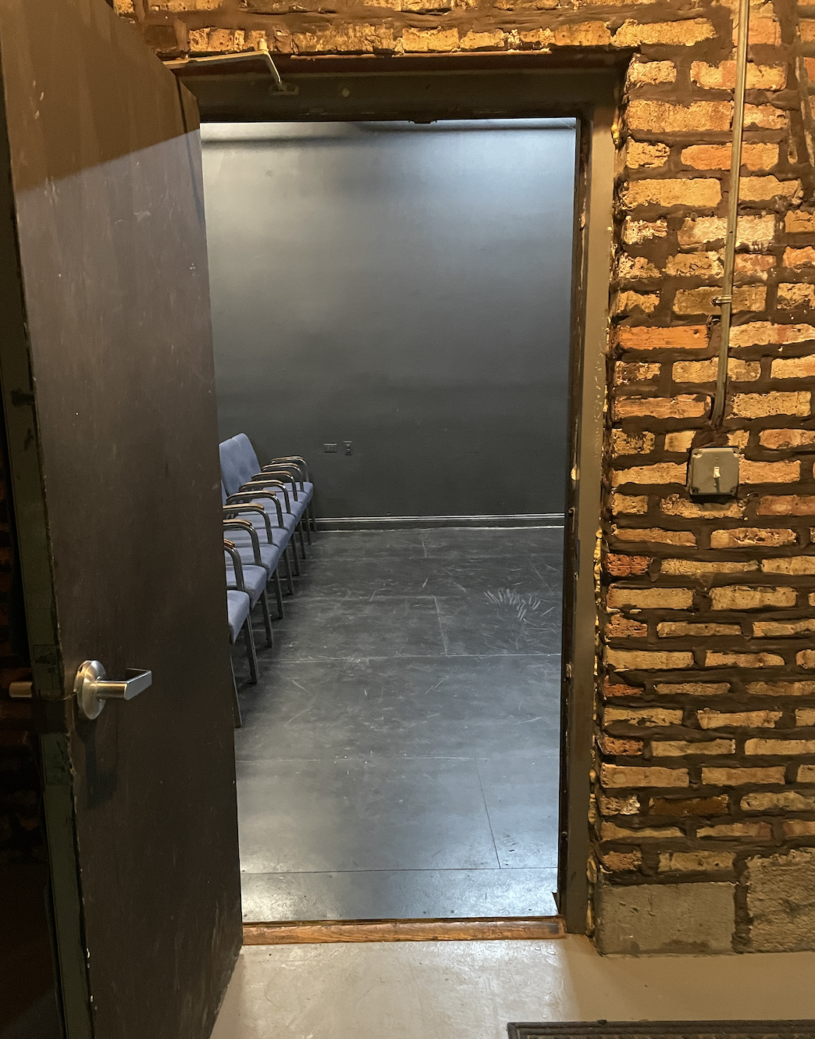
The doorway leading into the theatre space is 33.5 in. wide.

THE THEATRE

The seating area will be located directly past the door upon entering to the left. Seating configurations may change from performance to performance, but we are most often set up proscenium style, which means the audience all sits together, facing the stage.

Each seat can be secured to the seat next to it and is moveable/removeable for accessibility purposes. The first row of seating is on floor level. This allows for 7-13 feet of flexible seating area on floor level, depending on the production’s seating configuration.

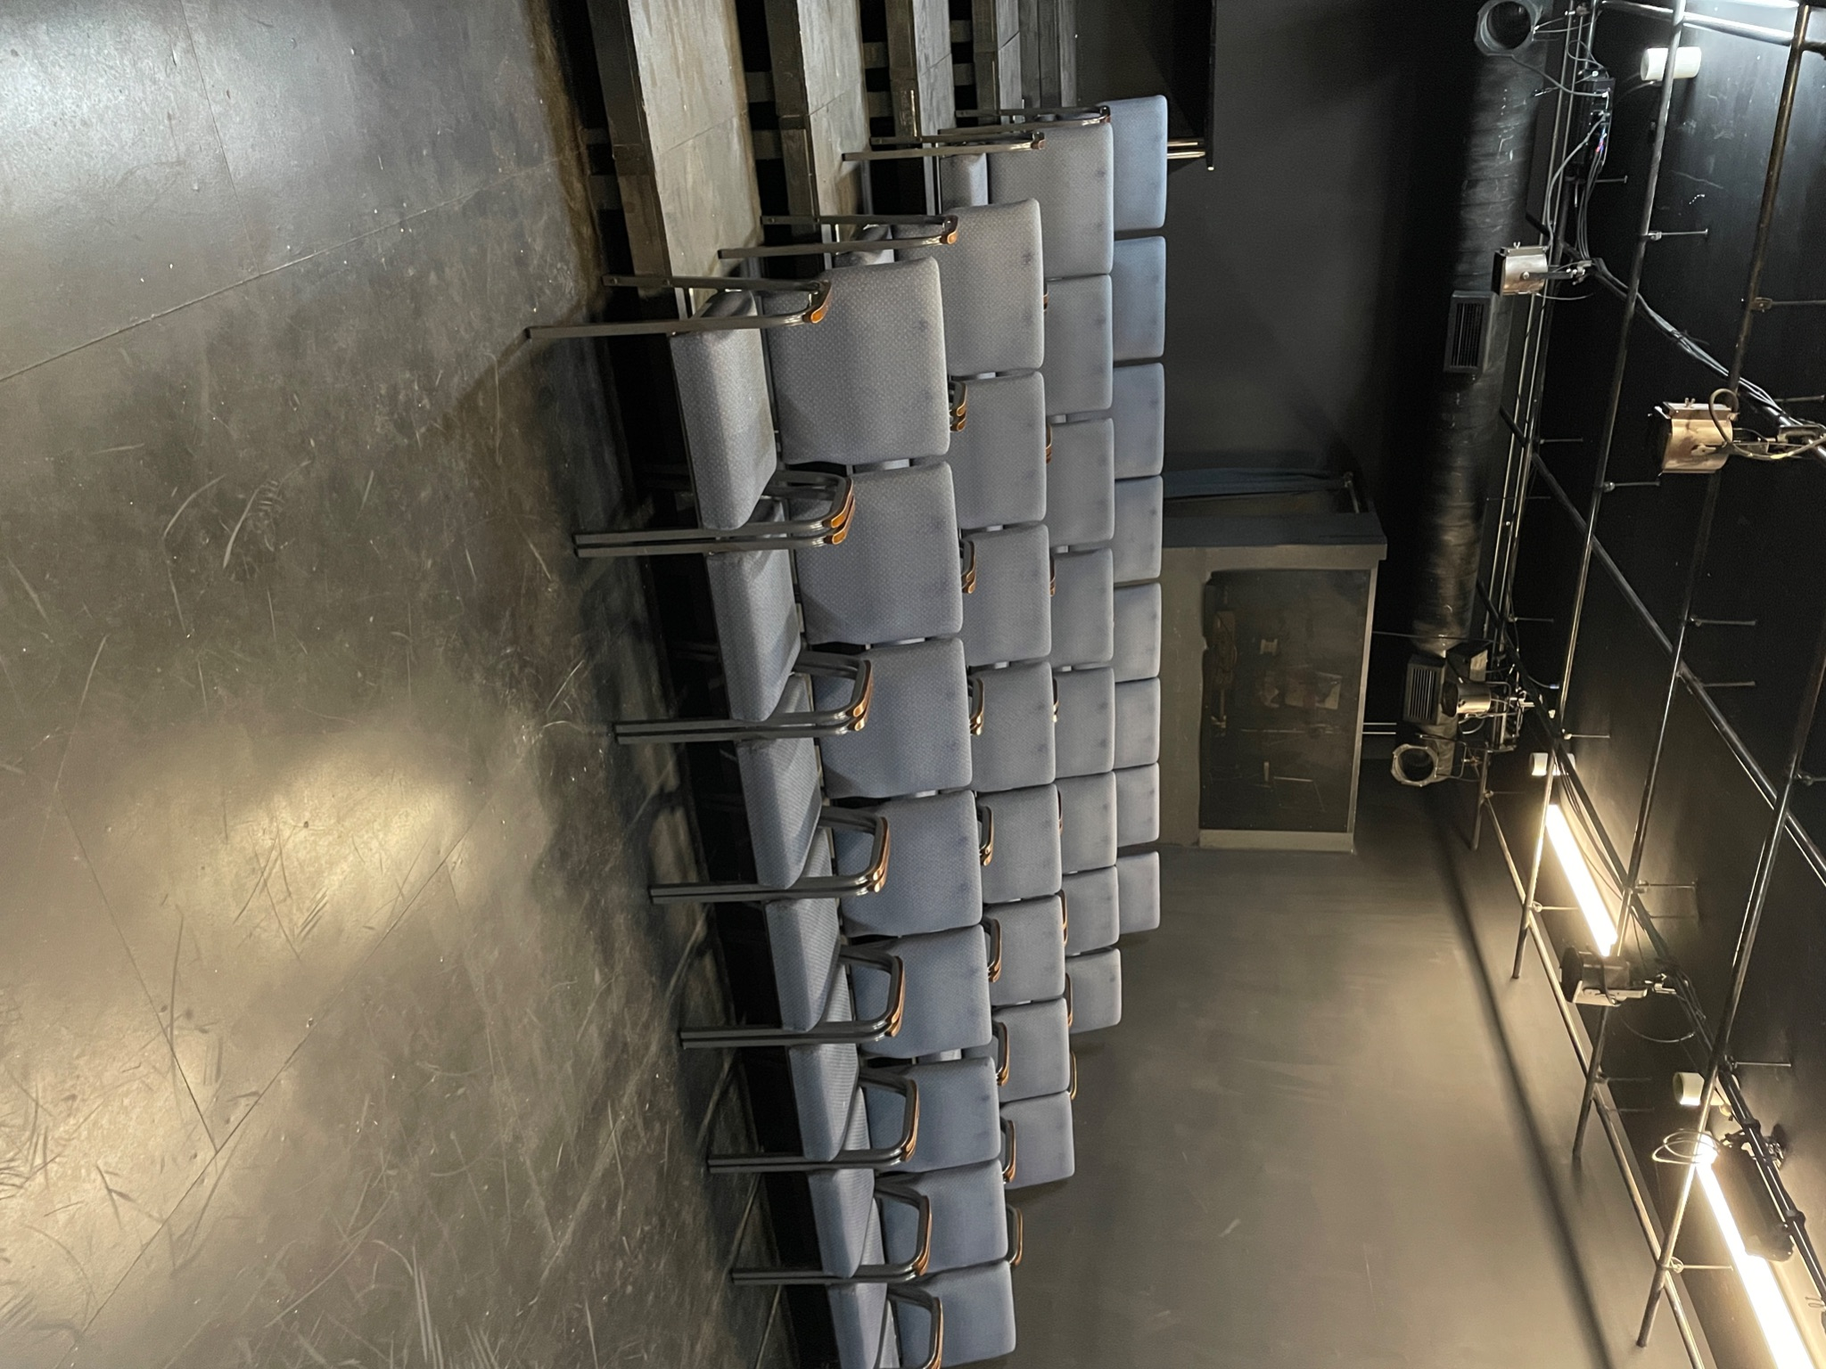
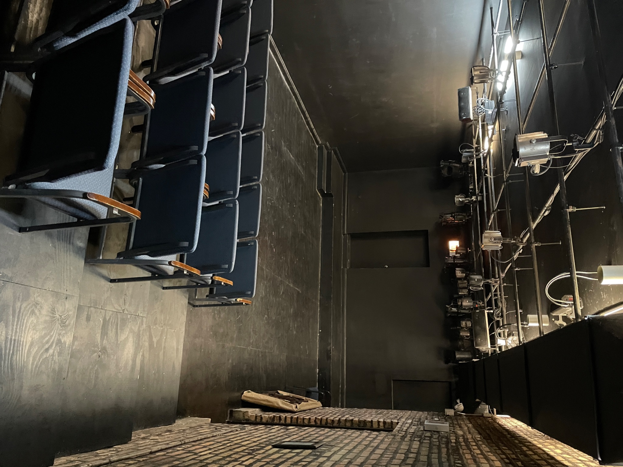
Tiered seating exists on five platforms behind floor level, each platform stretching wall to wall, and measuring 39" deep.
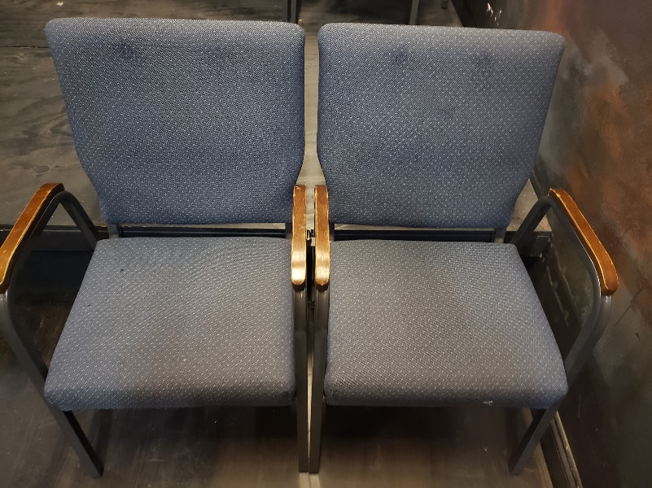

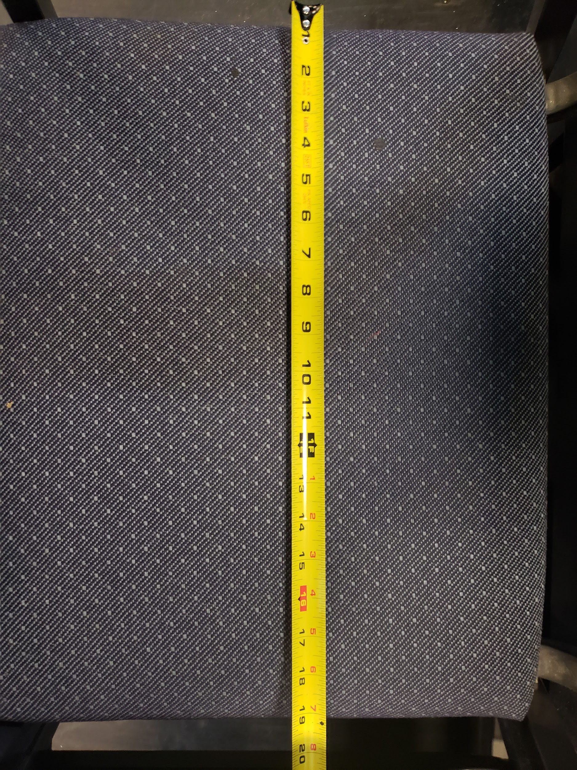
The width of each seat measures 19.5 inches wide.

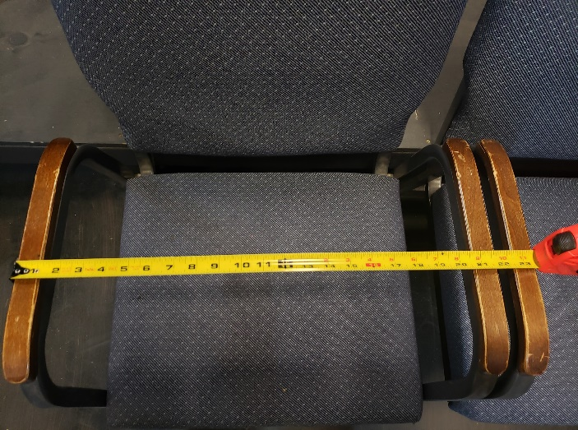

At the end of the performance, the theatre will go dark for a moment. Then, when the lights come back up, there may be applause, cheers, and sudden movements as audience members celebrate the artists and prepare to leave the theatre.

You will exit the theatre the same way you entered. We hope to see you again soon!

Founding Artistic Director Tara Mallen (center) at Blue Jean Ball 2019

FOLLOW / LIKE / CONTACT US

Rivendell Theatre Ensemble

Office:
5775 N. Ridge Ave.
Chicago, IL 60660

Theatre:
5779 N. Ridge Ave.
Chicago, IL 60660

Have questions about access or accommodations? Please contact us!
775-334-7728
info@rivendelltheatre.org

www.rivendelltheatre.org

